Part III Short answer question.
What are the characteristics of collectivism?

Part IV Please analyze the following case with reference to what you have learned in the book.

Please describe the following pictures: one is traditional Chinese landscape painting and the other is the western painting Mona Lisa. Then try to analyze the two pictures from the perspectives of worldviews or thought patterns. And explain why in detail.

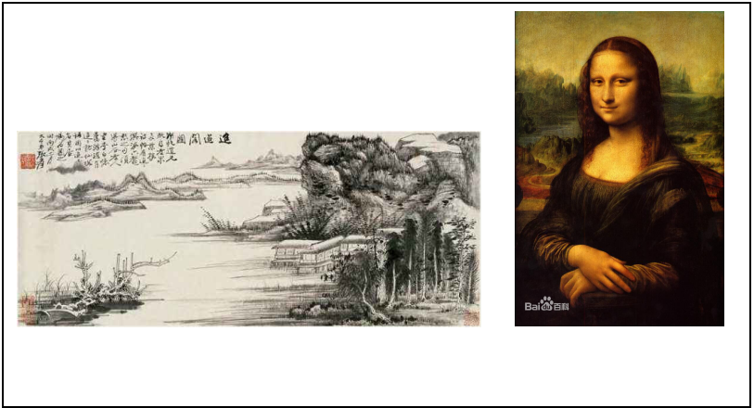

Holistic worldview refers to the notion that people tend to view the world as a whole, stressing the “One” “Unity” “Blending” “Integration” “Harmony” and “Wholeness”, etc.
Dualistic worldview means that people are likely to divide the world into two opposing (different) parts: subject and object, body and mind, man and nature, matter and form, etc.
P.41-49 (Holistic vs. Dualistic worldview)

P.110-111 (Contrast of Chinese thinking and western thinking)

Case analysis 1
Chinese cooking focuses on the intuition, synthesis (color, flavor, taste,etc), subjective, concrete and wholeness;
Western cooking: stresses the analysis, reasoning, precision, objectivity, and logic.
Case Analysis 2
Please analyze the following sentences and try to find out what concept of time is reflected respectively?
English expressions or proverbs: Time is money; He who hesitates is lost.
Chinese expressions or proverbs: Haste makes waste; Do not hurry and take it easy.

Case analysis 3
What family values are reflected in the extended family and nuclear family structure?

